ANIMAL CARTOON 2017, PETS

AWARDS

Two First prizes, 400 euro each
Cemalettin Guzeloglu TURKEY
Muhamed Djerlek Max SRBIJA

Two Second prizes, 300 euro each
Lazo Sredanović MONTENEGRO
Goran Ćeličanin SRBIJA

Two Third prizes, 200 euro each
Marcelo Ferreira BRASIL
Tsocho Peev BULGARIA

DIPLOMAS
Danja Doroški SRBIJA
Guibao Gai CHINA
Manuel Arriaga SPAIN
Zoran Tovirac SRBIJA
Klaus Pitter AUSTRIA
Vladimir Nenashev RUSSIA

JURY MEMBERS
Prof. dr Špiro Radulović (cartoonist, Srbija), jury president
Nenad Ostojić (cartoonist, Croatia)
Tošo Borković (cartoonist, Srbija)
Prof. Jugoslav Vlahović (cartoonist, Srbija)
Jovo Škomac (cartoonist, Srbija)

AWARDS
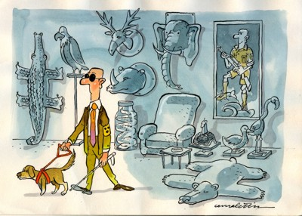 | 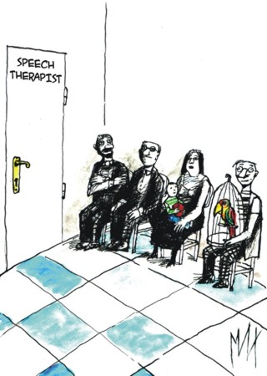
Cemalettin Guzeloglu TURKEY  First prize (400 euro) | Muhamed Djerlek Max SRBIJA  First prize (400 euro)
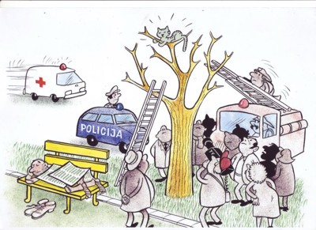 | 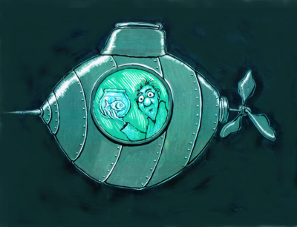
Lazo Sredanović MONTENEGRO  Second prize (300 euro) | Goran Ćeličanin SRBIJA  Second prize (300 euro)
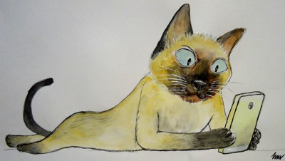 | 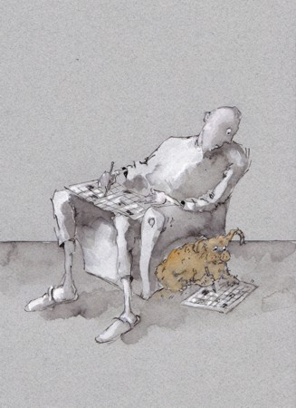
Marcelo Ferreira BRASIL  Third prize (200 euro) | Tsocho Peev BULGARIA  Third prize (200 euro)

DIPLOMAS
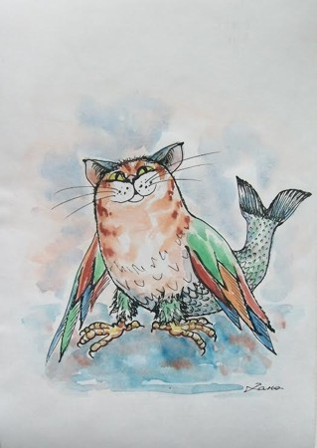 | 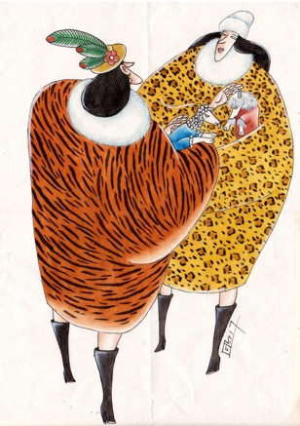
Ideal pet  Danja Doroški SRBIJA | Guibao Gai CHINA
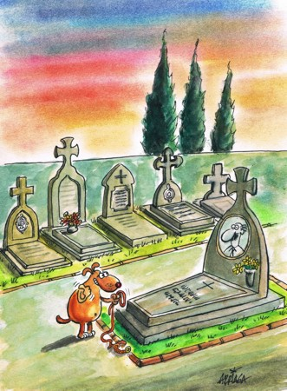 | 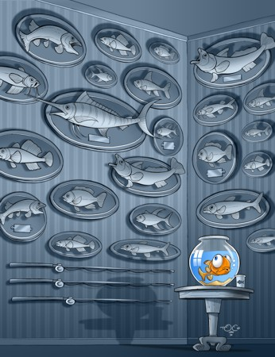
Manuel Arriaga SPAIN | Zoran Tovirac SRBIJA
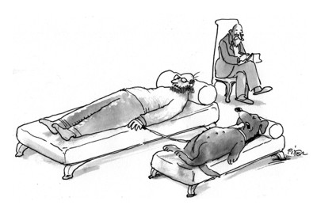 | 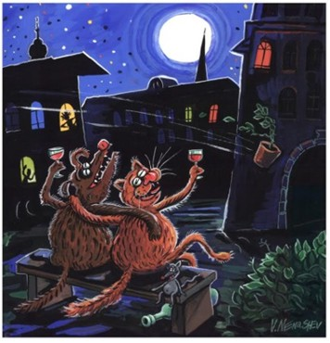
Klaus Pitter AUSTRIA | Vladimir Nenashev RUSSIA

