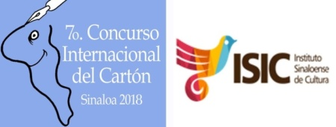

EL INSTITUTO SINALOANSE DE CULTURA INVITES TO THE
7TH INTERNATIONAL CARTOON CONTEST, SINALOA 2018

1. PARTICIPATION
The Contest is open to all cartoonists from all over the world and beyond.

2. THEME: VANITY
Is vanity inherent in the human being? Will a chimpanzee, who shares 99% of DNA with us, be a victim of this same trait?
Twin sister of narcissism, the dictionary also defines Vanity as: conceit, boasting, vainglory, haughtiness, presumption, pride, petulance, pedantry and fatuity; a key set of concepts imputed to the human species and capable of engendering the most terrible events. Think of the supposed supremacies that unleashed abominable genocides, the arms race, space warfare, empires, dynasties, and other kind of atrocities which have devastated cultures and nations.
But vanity does not stop there; it goes beyond the bounds of the social and changes its skin at will. It explores the entrails of the individual and becomes the central axis of a system based on compulsive consumerism, a permanent competition that demands the possession of the most expensive objects, the latest technology and the most perfect bodies: a super status quo that awards the title of "The best of all". Thus, without realizing, we repeat models of dictators decorated with fake medals and elite ladies who attach pillows to increase their bottoms. In this ocean of superfluous values, ​​is it possible to navigate without taking on water?

3. THE PRIZES
1st Prize: $30,000 Mexican pesos.
2nd Prize: $20,000 Mexican pesos.
3rd Prize: $15,000 Mexican pesos.

Winners will be notified by e-mail from 29th November 2018.

4. ENTRIES
A maximum of 3 works can be submitted by E-mail in any media, in black and white or colour, but they should not be currently participating in other contests or have been awarded.
Works should have a minimum resolution of 200 dpi, size 21.5cms x 27.9cms. They should be sent to any one of the following:
concursosinaloa2018@gmail.com
2concursosinaloa2018@gmail.com
camino3@prodigy.net.mx

5. DEADLINE: November 18th 2018.

6. PLEASE FILL IN THE ENTRY FORM AND SEND IT TOGETHER WITH YOUR WORK
(The entry form can be downloaded from http://concursosinaloa2018.orgfree.com).

. Name
. Photograph
. Address
. E-mail

7. A catalogue with the winners and selected works will be available on the web page of the contest:
http://concursosinaloa2018.orgfree.com

8. Participants that were winners in 2017 can participate but if they win again they will only be entitle to receive honorary mentions.

9. PROPERTY RIGHTS
Copyright belongs to authors. The Contest will use some works, but only for promotional purposes, such as publicity, the catalogue and the press.

